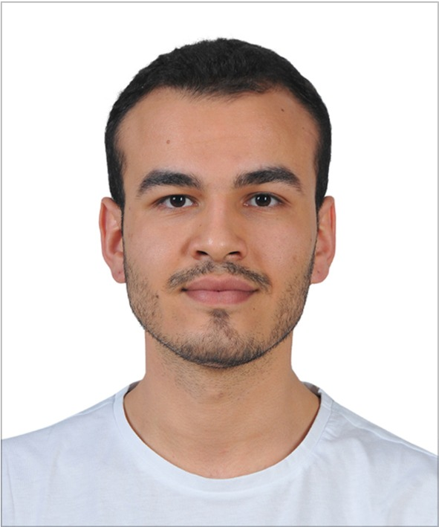**Emre Deniz ŞENEL**

Undergraduate Senior Student of Electrical & Electronics Engineering of Middle East Technical University

Location: Ankara / Turkey

Telephone: +90 539 587 02 18

E-mail: emre.senel@metu.edu.tr

Professional profile

After graduating from the high-school I became 749th in the university entrance exam (YGS-LYS) in Turkey in 2015. Currently, I am a senior student of Electrical & Electronics Engineering in METU. My interests are power electronics, electric vehicles and autonomous systems. Current, I am conducting two STAR EEE Projects in my university on induction machines and autonomous driving systems. My goal is to establish my own electrical autonomous vehicle brand.

Career Summary

**June 2019 – July 2019 ASELSAN Electronics Inc., Ankara**

**Student Intern**

*Outline*

As a summer intern, my goal was to observe defence industry and experience practical implementations of my theoretical background.

*Key responsibilities*

* Designed interfaces using MATLAB and GUIDE software.
* Analysed intrinsic and extrinsic parameters of cameras.
* Implemented a simulation software of a camera.
* Analysed different feature detection and feature extraction algorithms.
* Tested runtimes of different matching algorithms.

**July 2018 – September 2018 TOYOTA Motor Manufacturing Turkey, Sakarya**

**Student Intern**

*Outline*

TOYOTA’s manufacturing system is observed. Analysed assembly division problems and conducted a symptom management project in maintenance engineering department.

*Key responsibilities*

* Controlled and observed the manufacturing process of the TOYOTA assembly factory.
* Joined to the meetings and observed how project management is done.
* Conducted a symptom management project which is a dust sensor.
* Joined Programmable Logic Controller tutorials and built a short-run code.

Education and qualifications

* **Electrical & Electronics Engineering B.S,** Middle East Technical University, 2015 – Present (Currently Senior Student), CGPA 3.44/4.00
* **High School Graduate,** Gazi Anatolian High School, 2011 – 2015, Grade 93.06/100.00
* **Primary School Graduate,** Evrensel Primary School, 2004 – 2011

Projects and Publications

**Coordination of Autonomous Electrical Vehicles for Energy Efficient Driving**, METU EEE STAR Project, May 2019 - Present

**Induction Machine Test Setup Development**, METU EEE STAR Project, May 2019 – Present

**Pinball Game Design with VHDL**, METU EEE Logic Design Project, February 2019 – June 2019

**Wireless Communication System Design,** METU EEE Analog Design Project, September 2018 – February 2019

**Fire Alarm System Design**, METU EEE Circuit Laboratory Project, February 2018 – June 2018

**Solar Tracking System Design,** METU EEE Circuit Laboratory Project, September 2017 – February 2018

Organizations and Achievements

**Aegean Conference on Electrical Machines and Power Electronics (ACEMP)**, August 2019, Turkey – Organization Team Member

**Borusan Atölye Robothon**, November 2019, Turkey – Winning Team Member

Skills

* MATLAB Programming
* C Programming
* MS Office
* Simulink
* VHDL Programming
* Leadership

Languages

* **Turkish** - Fluent
* **English -** Advanced
* **French** – Elementary

Hobbies

* Chess
* Bass Guitar
* Formula 1
* Fitness